**MYSQL task day 1**

**Exercise 1— Tasks completed**

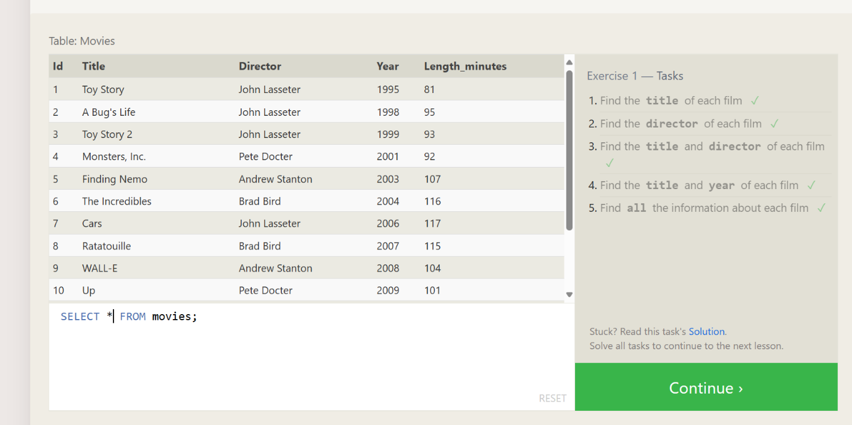

**Exercise 2— Tasks completed**

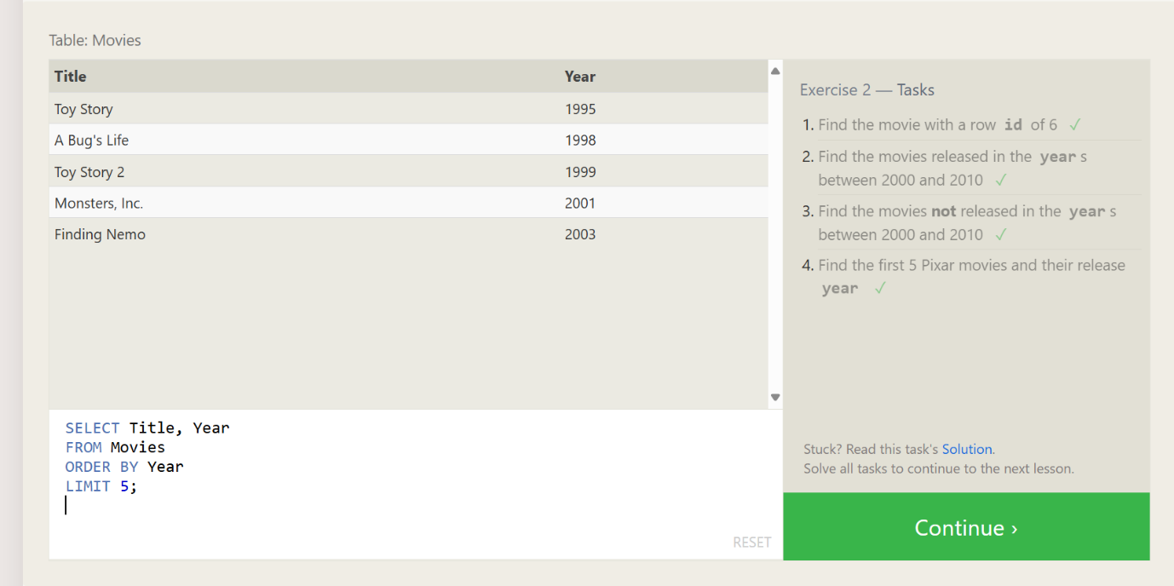

**Exercise 3— Tasks completed**

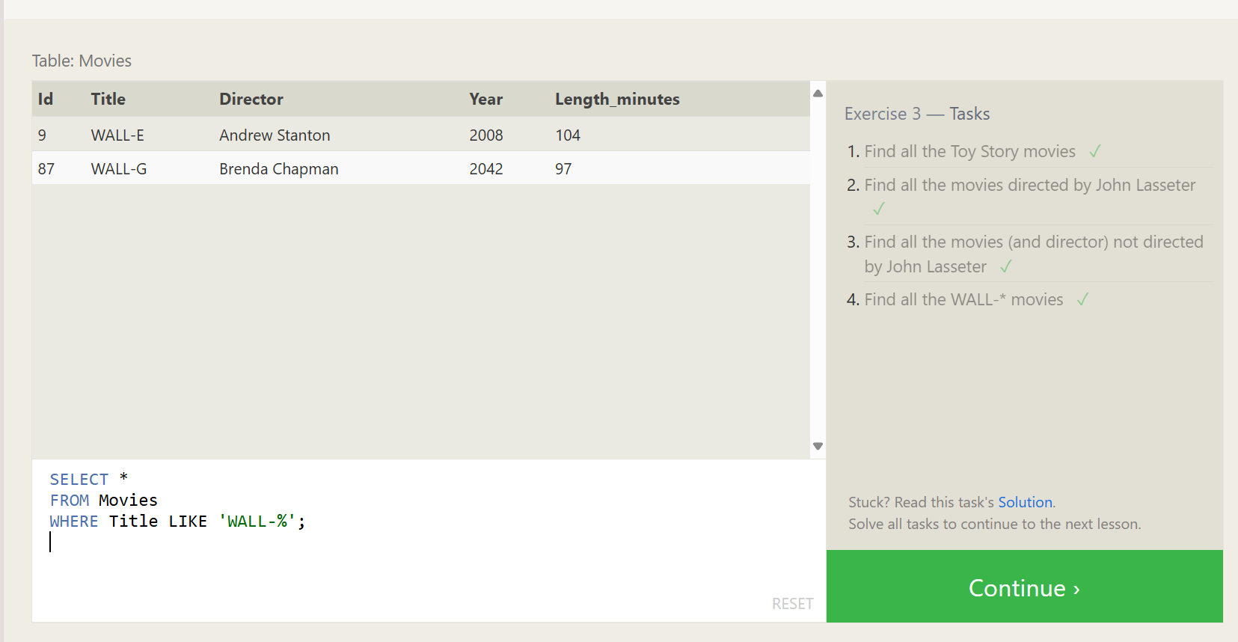

**Exercise 4 — Tasks**

1. **List all directors of Pixar movies (alphabetically), without duplicates?**

**QUERY:**

**SELECT DISTINCT Director**

**FROM Movies**

**ORDER BY Director;**

**OUTPUT:**

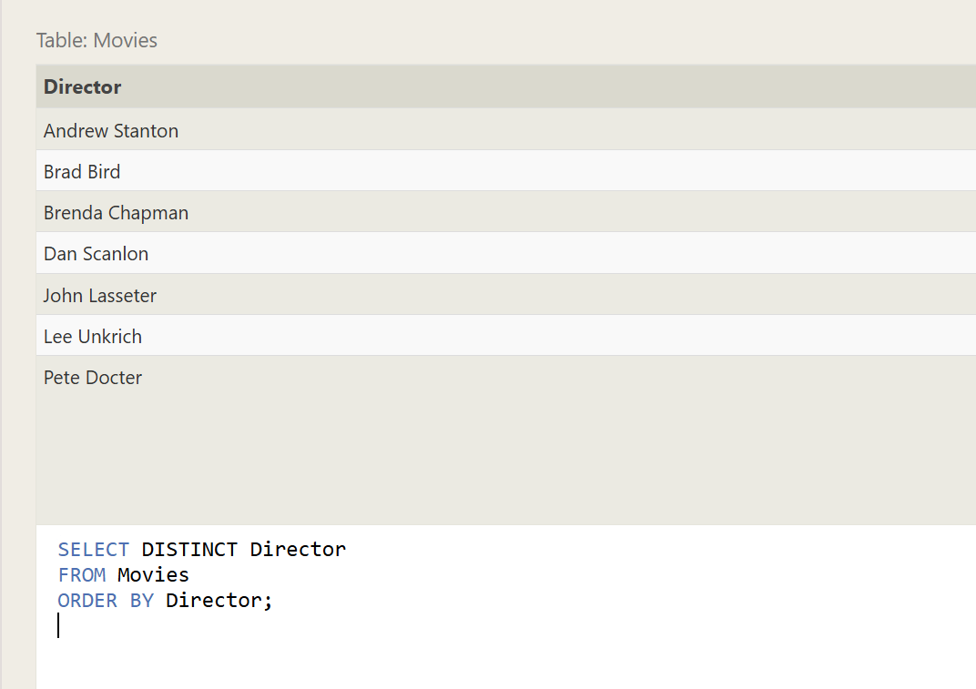

**2.List the last four Pixar movies released (ordered from most recent to least)**

**QUERY:**

**SELECT \***

**FROM Movies**

**ORDER BY Year DESC**

**LIMIT 4;**

**OUTPUT:**



**3. List the first five Pixar movies sorted alphabetically**

**QUERY:**

**SELECT \***

**FROM Movies**

**ORDER BY Title**

**LIMIT 5;**

**OUTPUT:**

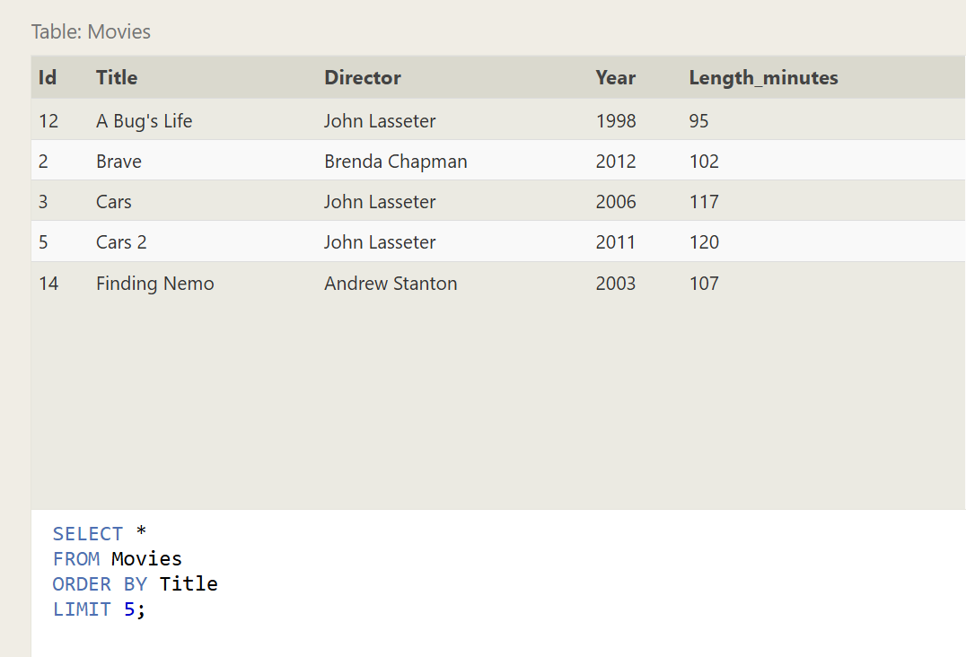

4. List the **next** five Pixar movies sorted alphabetically

**QUERY:**

**SELECT \***

**FROM Movies**

**ORDER BY Title**

**LIMIT 5 OFFSET 5;**

**OUTPUT:**



**EX-4 COMPLETED:**

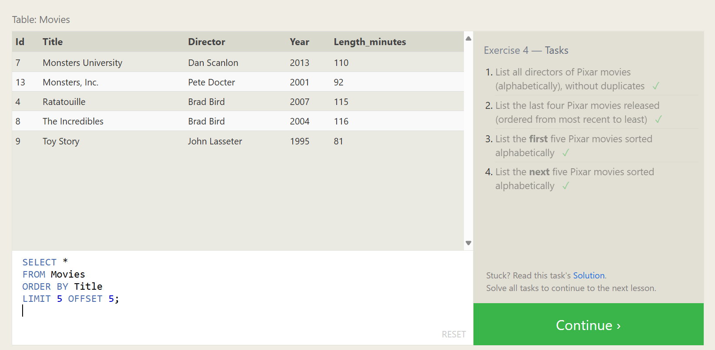

**Review 1 — Tasks**

**1.List all the Canadian cities and their populations:**

**QUERY:**

**SELECT City, Population**

**FROM North_american_cities**

**WHERE Country = 'Canada';**

**OUTPUT:**

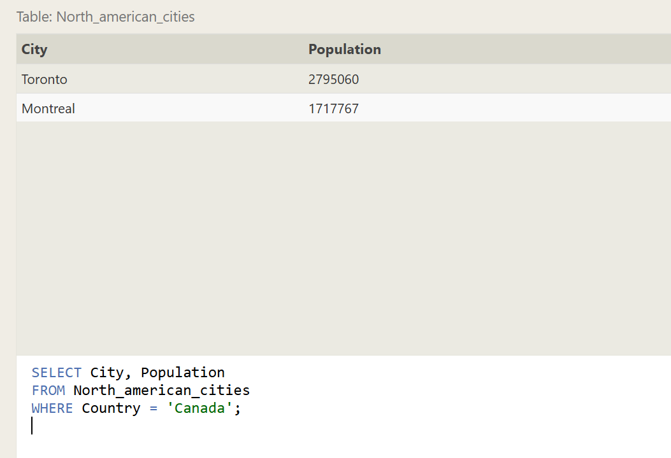

**2.Order all the cities in the United States by their latitude from north to south:**

**QUERY:**

**SELECT City, Latitude**

**FROM North_american_cities**

**WHERE Country = 'United States'**

**ORDER BY Latitude DESC;**

**OUTPUT:**

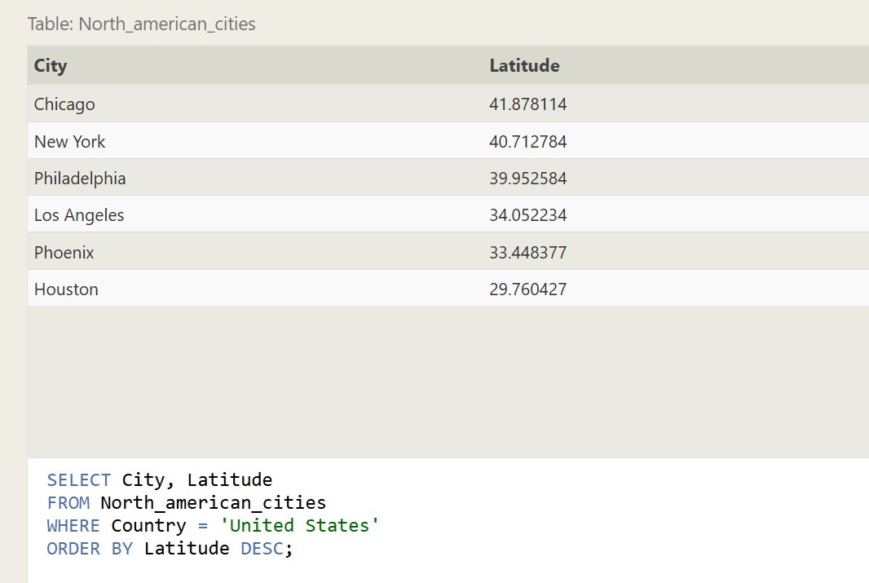

**3.List all the cities west of Chicago, ordered from west to east:**

**QUERY:**

**SELECT City, Country, Population, Latitude, Longitude**

**FROM North_american_cities**

**WHERE Longitude < -87.629798**

**ORDER BY Longitude ASC;**

**OUTPUT:**

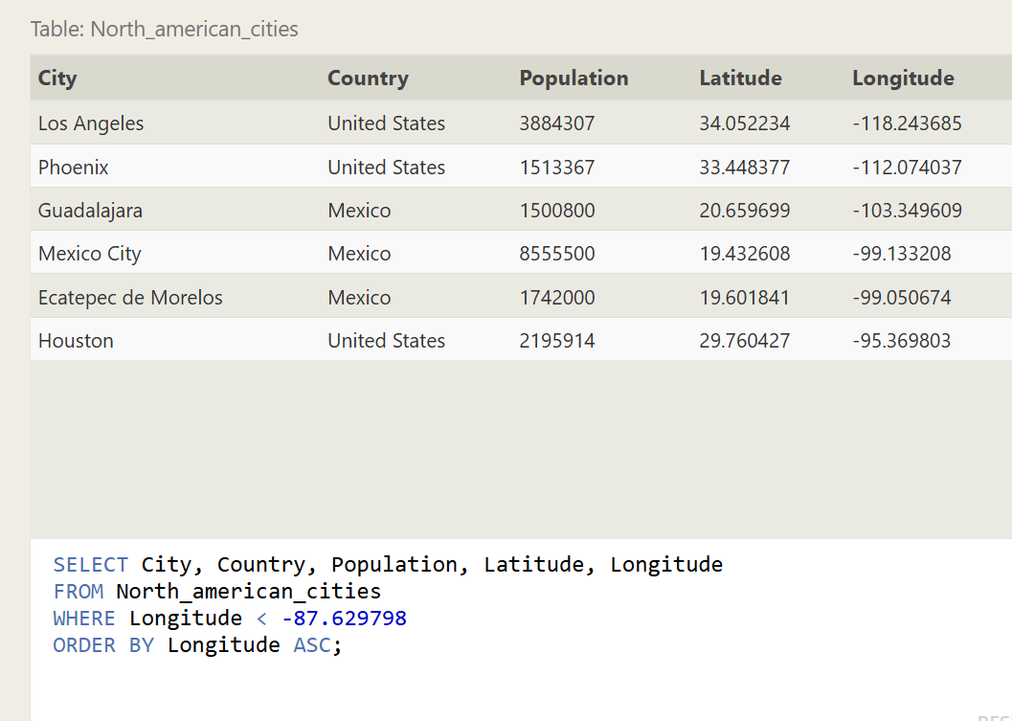

**4.List the two largest cities in Mexico (by population):**

**QUERY:**

**SELECT City, Population**

**FROM North_american_cities**

**WHERE Country = 'Mexico'**

**ORDER BY Population DESC**

**LIMIT 2;**

**OUTPUT:**

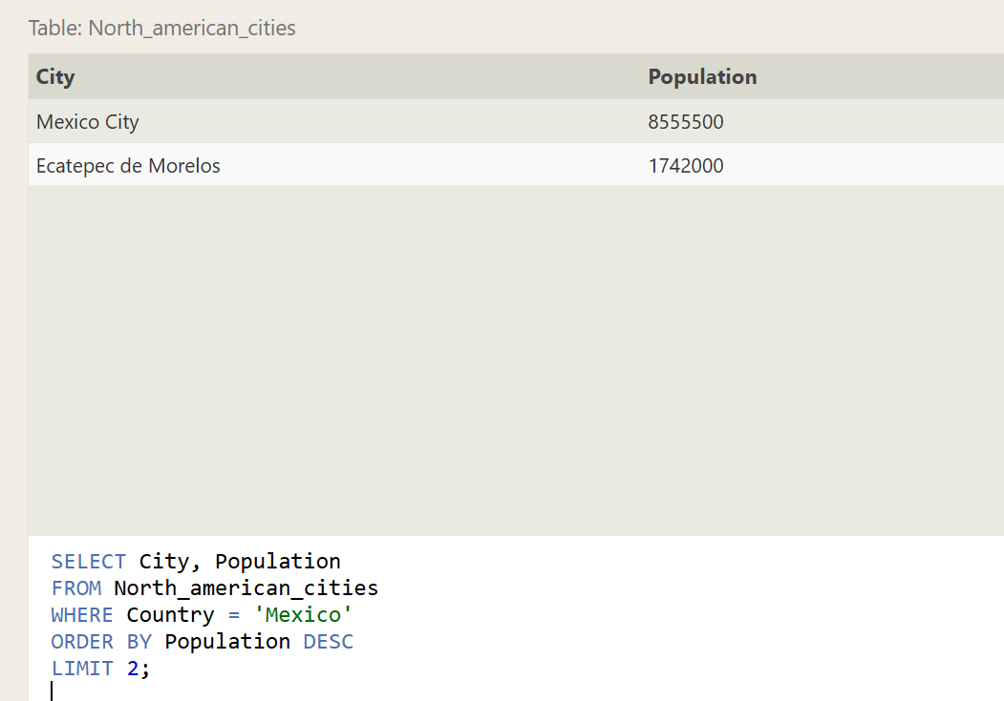

**5.List the third and fourth largest cities (by population) in the United States and their population:**

**QUERY:**

**SELECT City, Population**

**FROM North_american_cities**

**WHERE Country = 'United States'**

**ORDER BY Population DESC**

**LIMIT 2 OFFSET 2;**

**OUTPUT:**

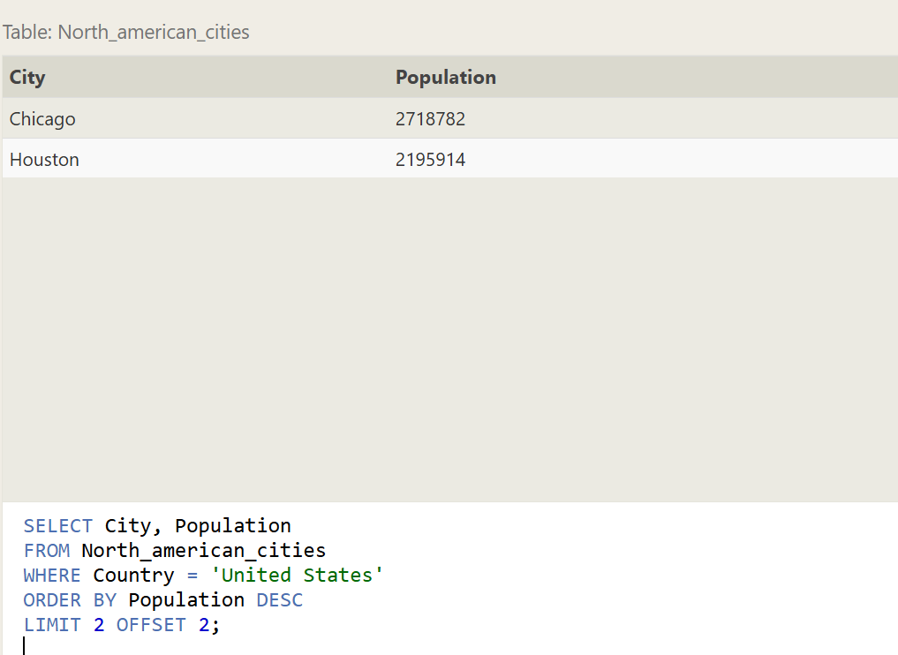

**Review 1 — Tasks completed:**

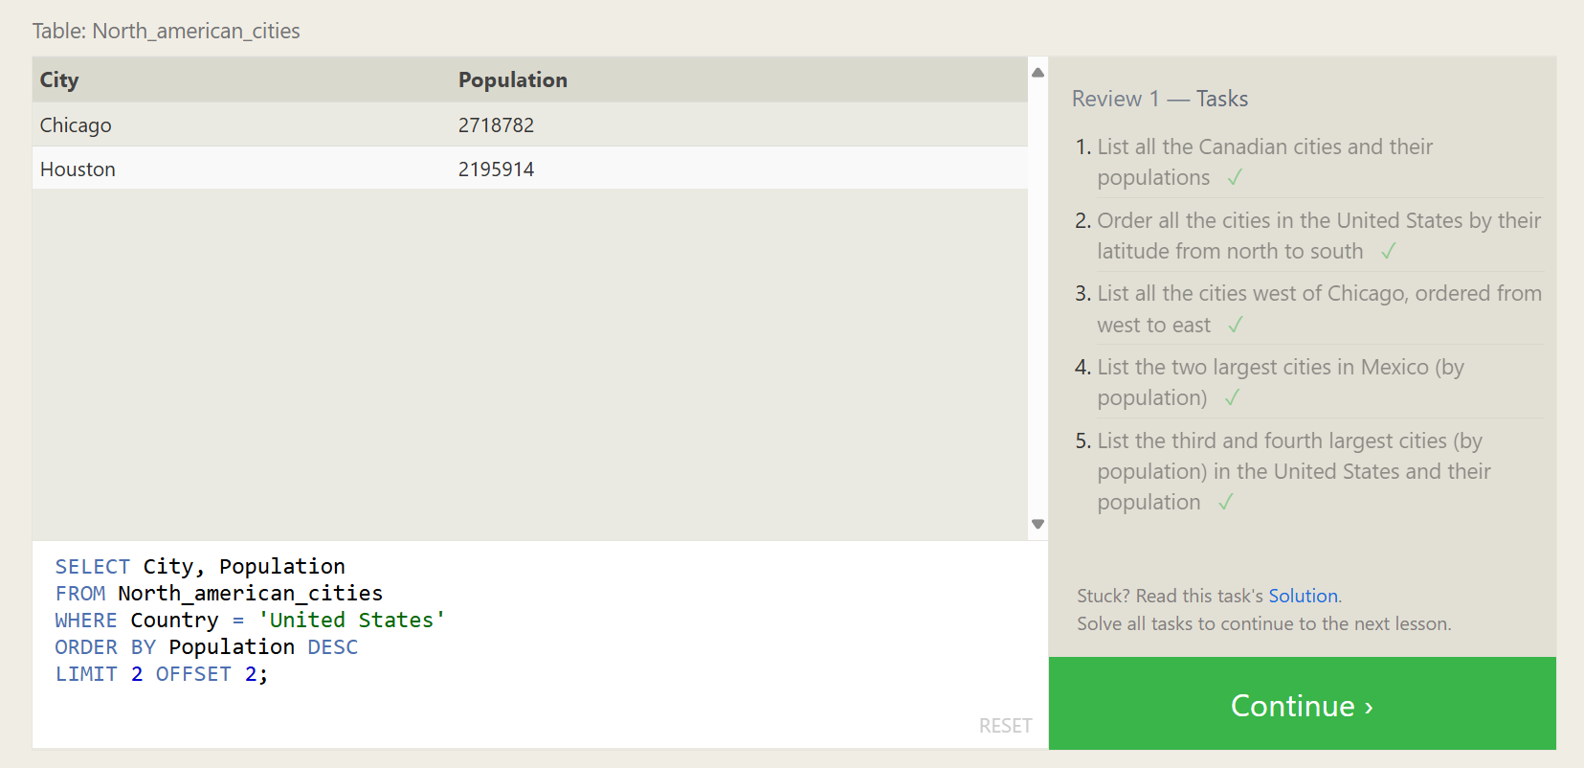

**Exercise 6 — Tasks**

**1.Find the domestic and international sales for each movie:**

**QUERY:**

**SELECT m.Title, b.Domestic_sales, b.International_sales**

**FROM Movies m**

**JOIN Boxoffice b ON m.Id = b.Movie_id;**

**OUTPUT:**

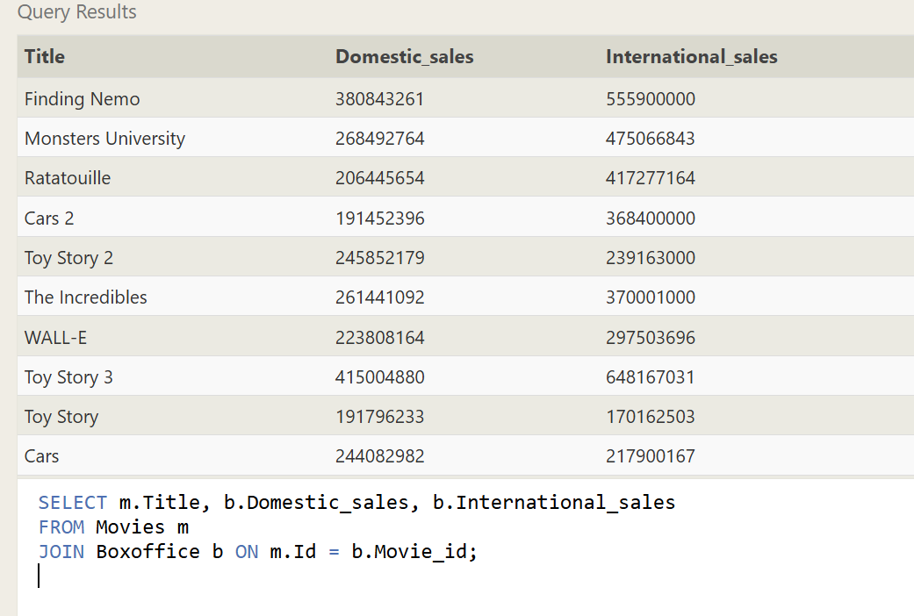

**2.Show the sales numbers for each movie that did better internationally rather than domestically:**

**QUERY:**

**SELECT m.Title, b.Domestic_sales, b.International_sales**

**FROM Movies m**

**JOIN Boxoffice b ON m.Id = b.Movie_id**

**WHERE b.International_sales > b.Domestic_sales;**

**OUTPUT:**

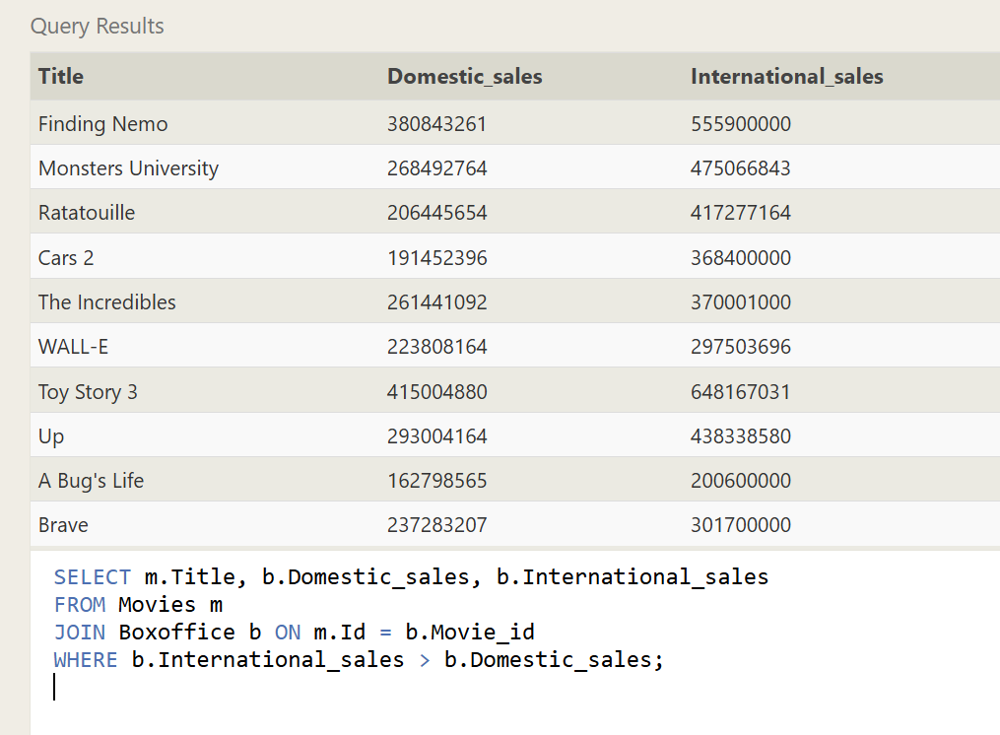

**3.List all the movies by their ratings in descending order:**

**QUERY:**

**SELECT m.Title, b.Rating**

**FROM Movies m**

**JOIN Boxoffice b ON m.Id = b.Movie_id**

**ORDER BY b.Rating DESC;**

**OUTPUT:**

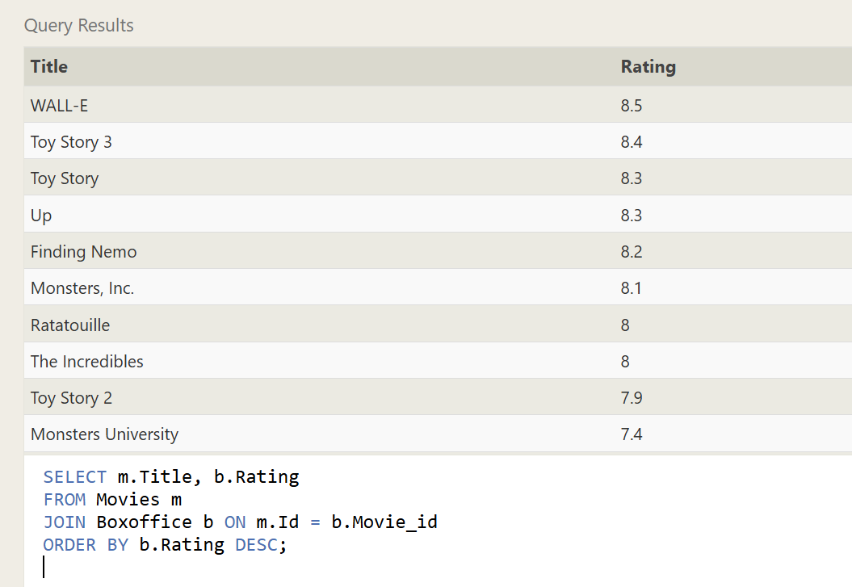

**Exercise 6 — Tasks completed:**

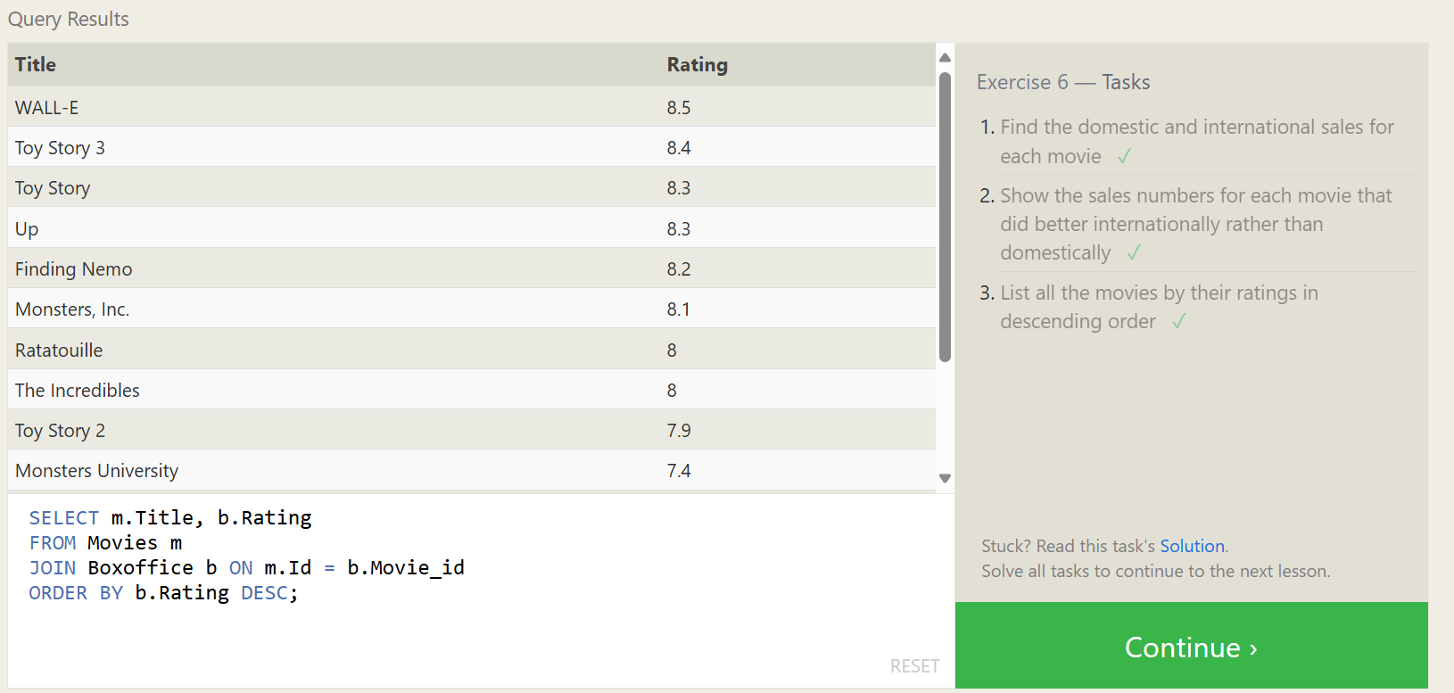

**Exercise 7 — Tasks**

1. **Find the list of all buildings that have employees**

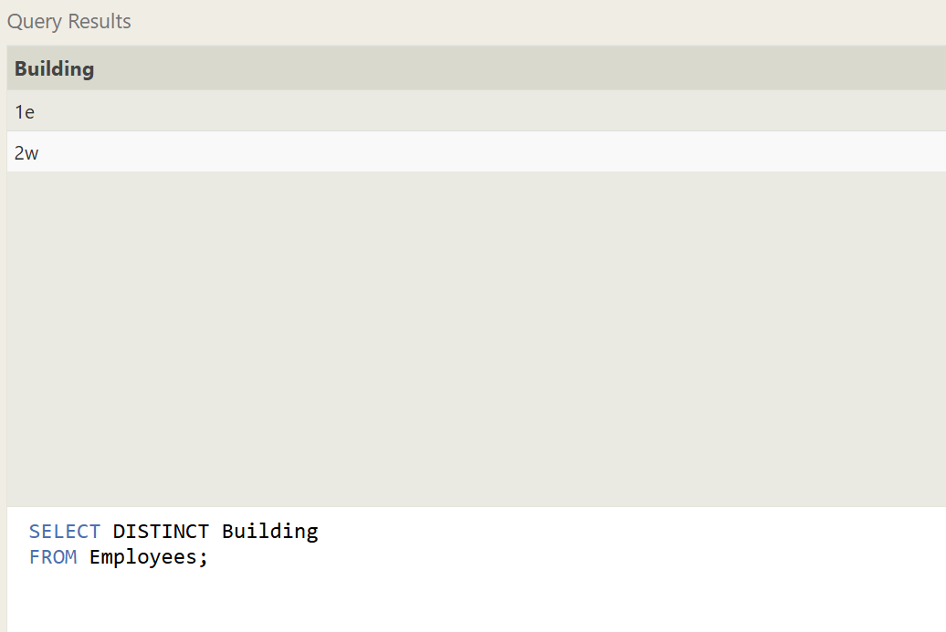

1. **Find the list of all buildings and their capacity**

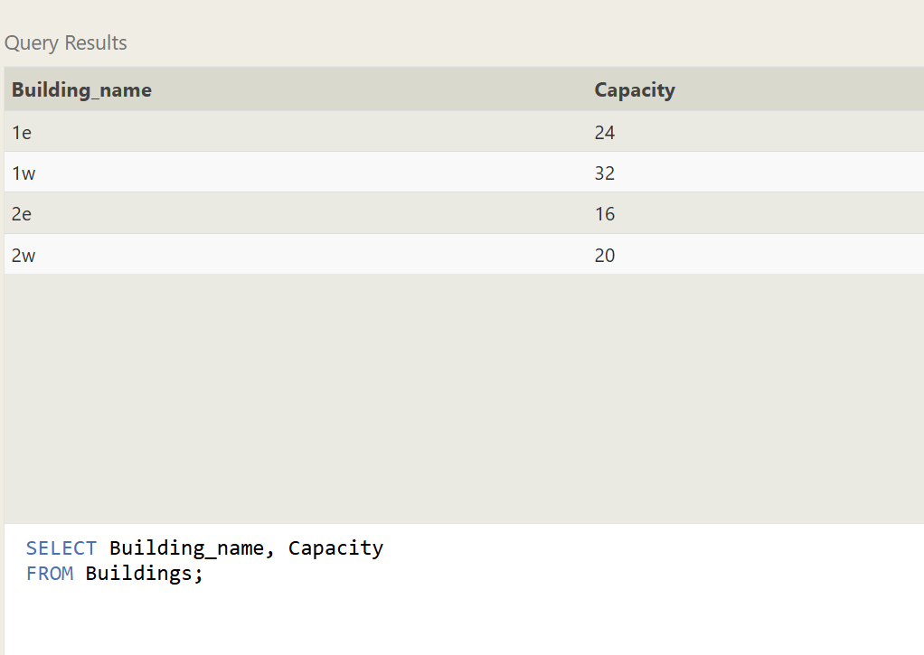

1. **List all buildings and the distinct employee roles in each building (including empty buildings)**

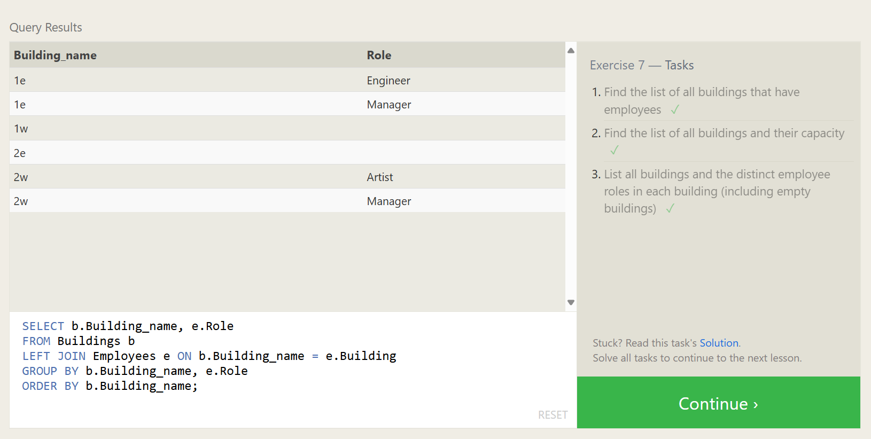

**Exercise 7 — Tasks completed**



**Exercise 8 — Tasks**

1. **Find the name and role of all employees who have not been assigned to a building**

SELECT Name, Role

FROM Employees

WHERE Building IS NULL OR Building = '';

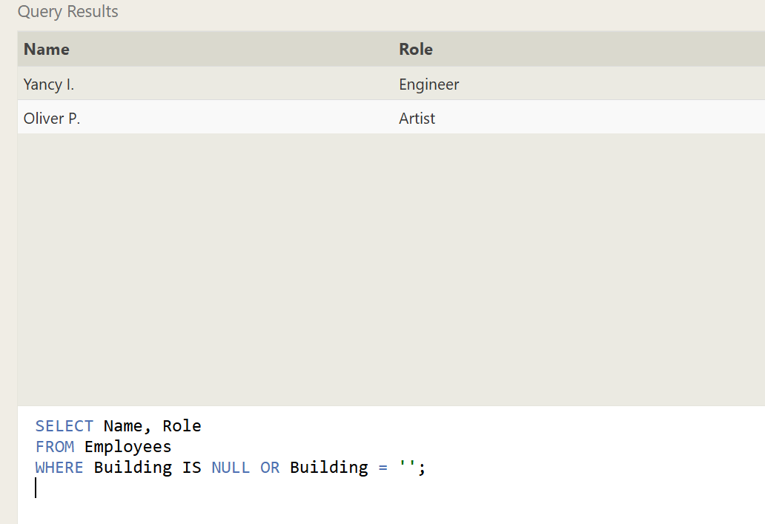

1. **Find the names of the buildings that hold no employees**

SELECT b.Building_name

FROM Buildings b

LEFT JOIN Employees e ON b.Building_name = e.Building

WHERE e.Building IS NULL

GROUP BY b.Building_name;

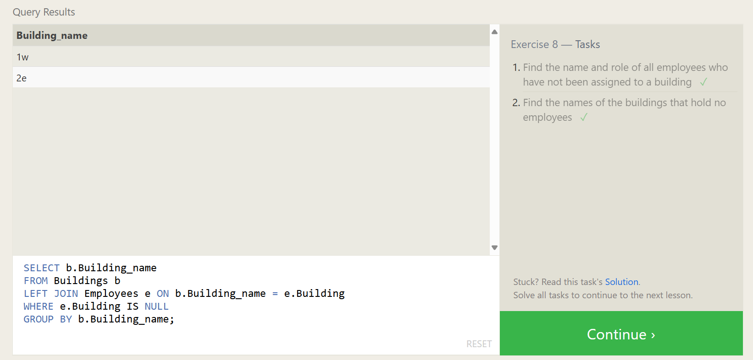

**Exercise 8 — Tasks Completed:**



**Exercise 9 — Tasks**

1. **List all movies and their combined sales in millions of dollars**

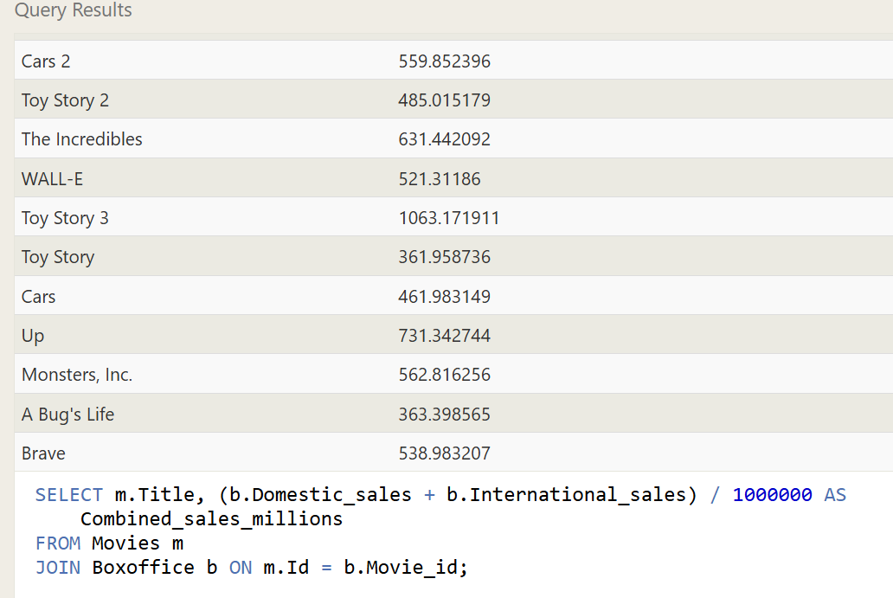

1. **List all movies and their ratings in percent**

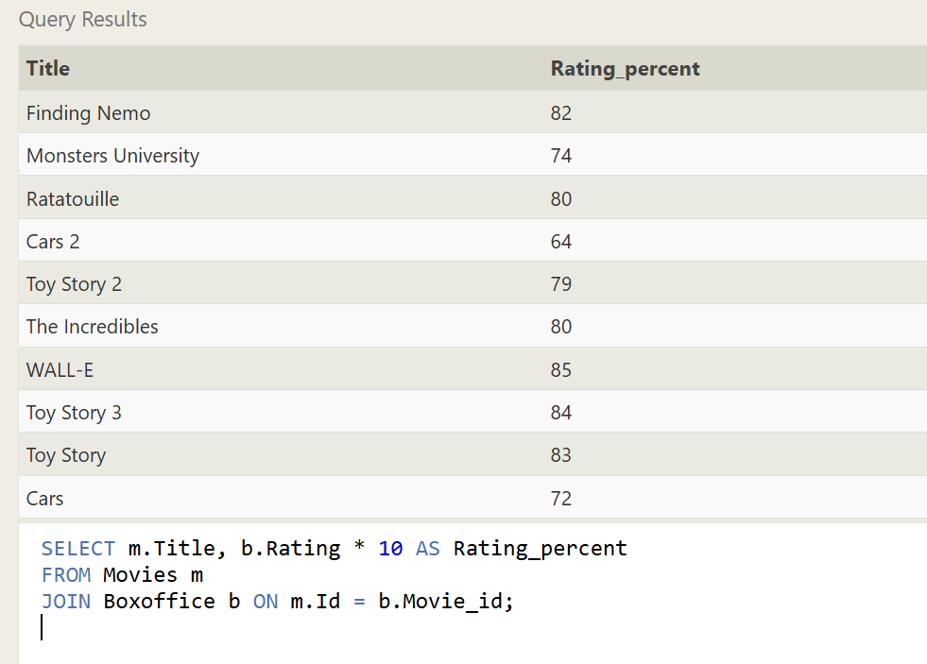

1. **List all movies that were released on even number years**

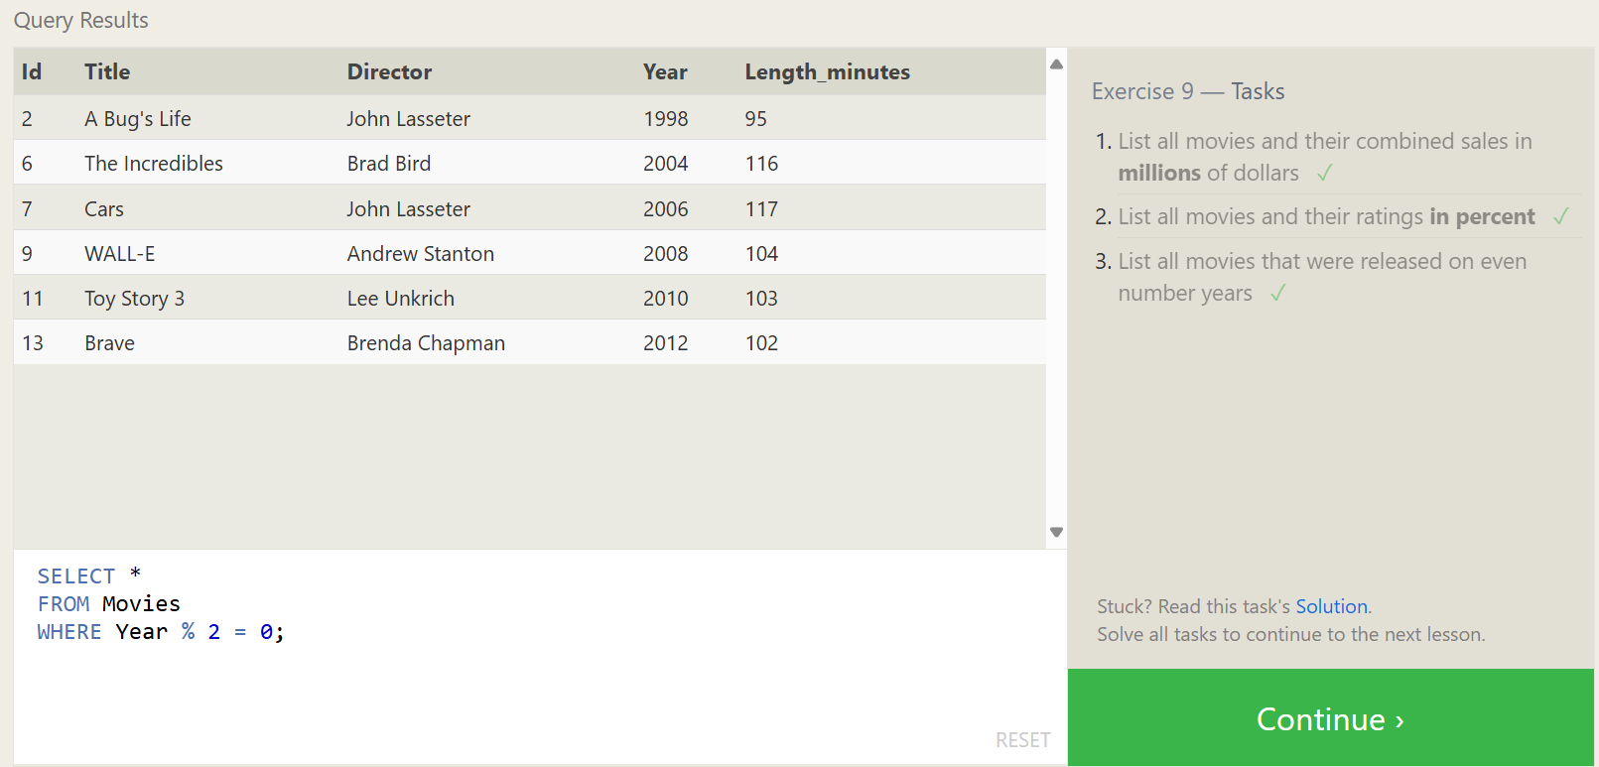

**Exercise 9 — Tasks Completed:**



**Exercise 10 — Tasks**

1. **Find the longest time that an employee has been at the studio**

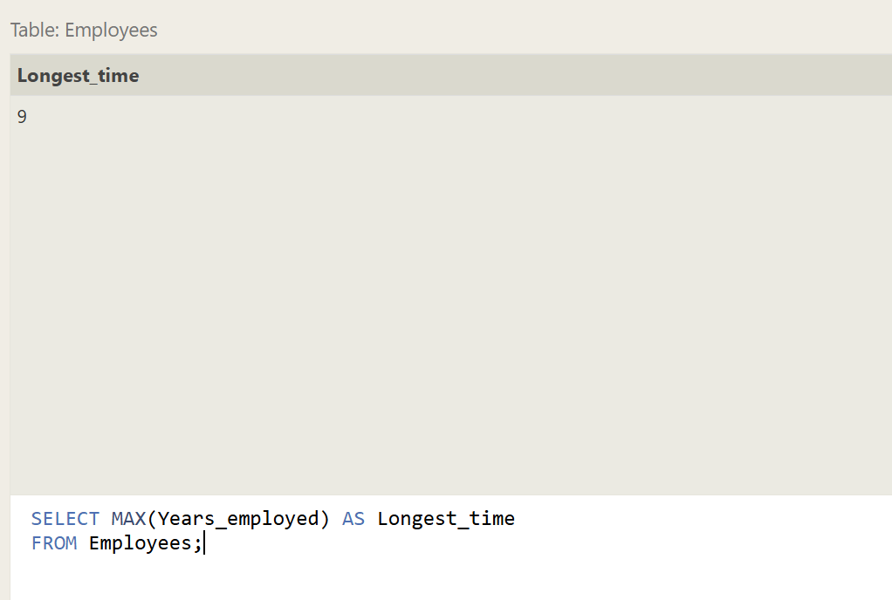

1. **For each role, find the average number of years employed by employees in that role**

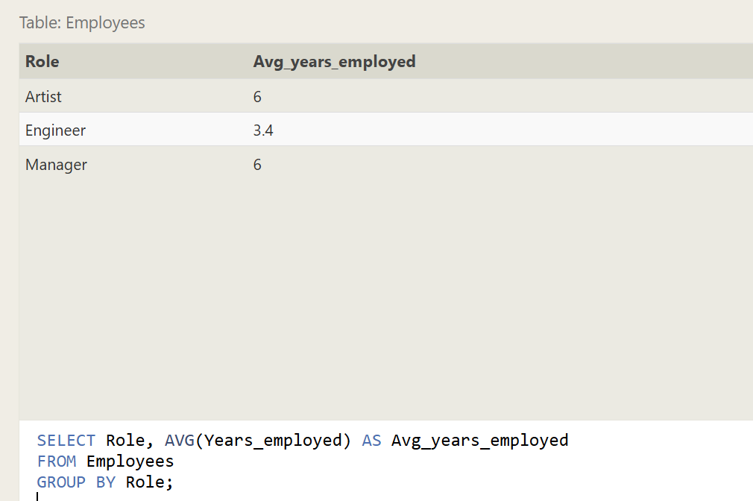

1. **Find the total number of employee years worked in each building**

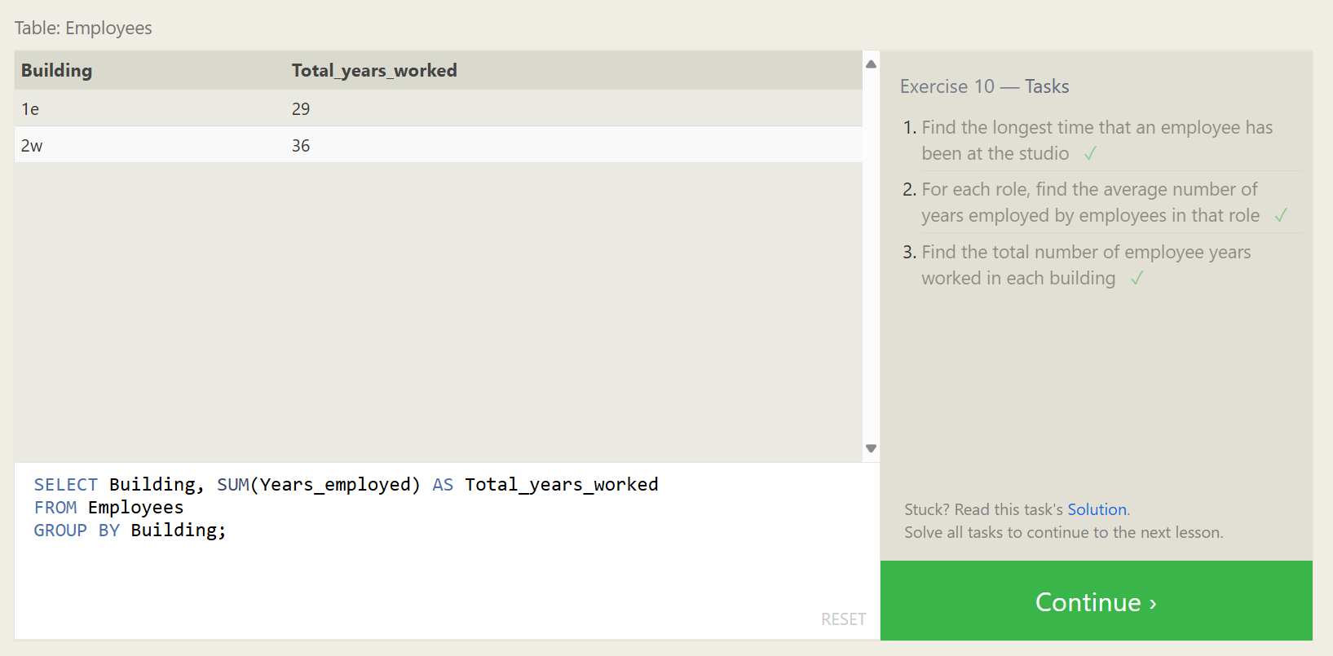

**Exercise 10 — Tasks Completed:**



**Exercise 11 — Tasks Completed:**

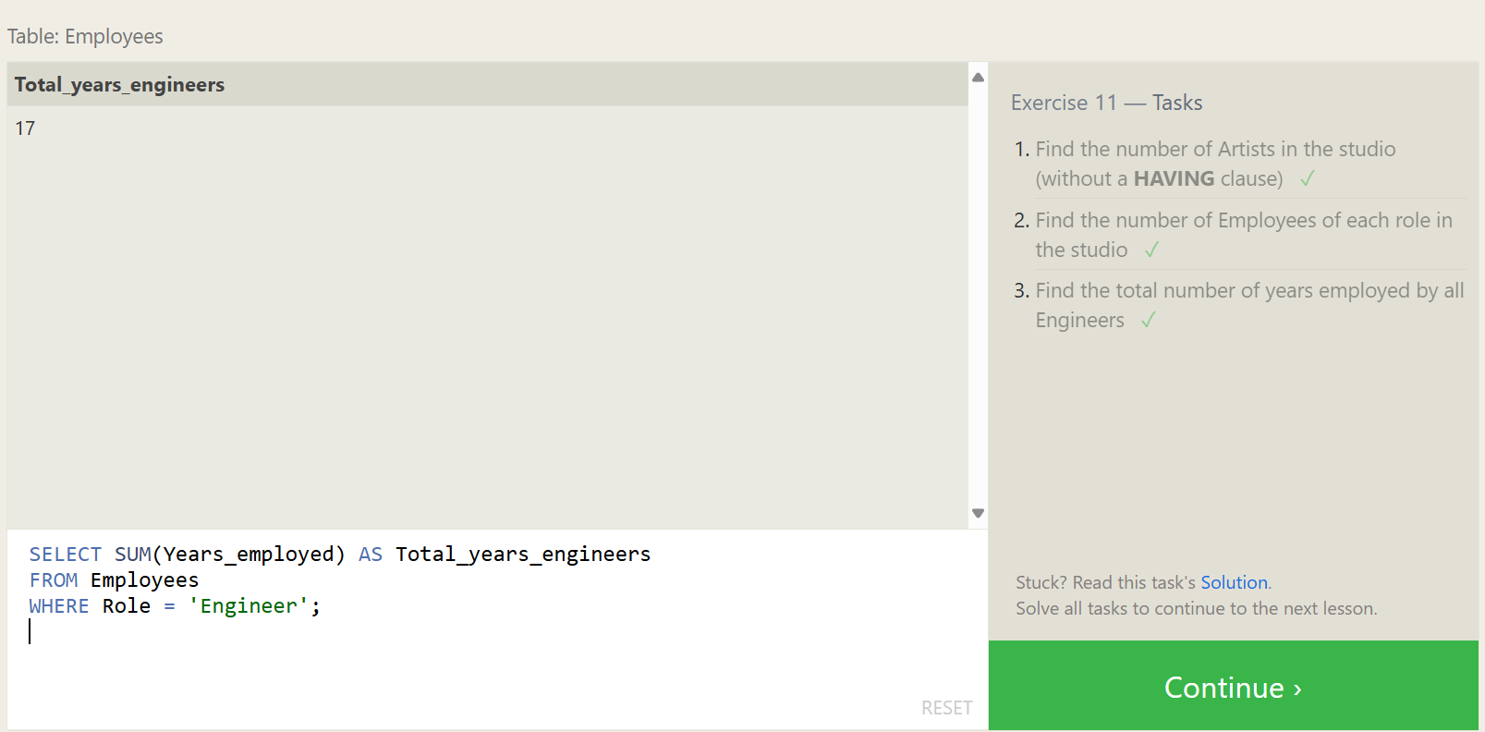

**Exercise 12 — Tasks Completed:**

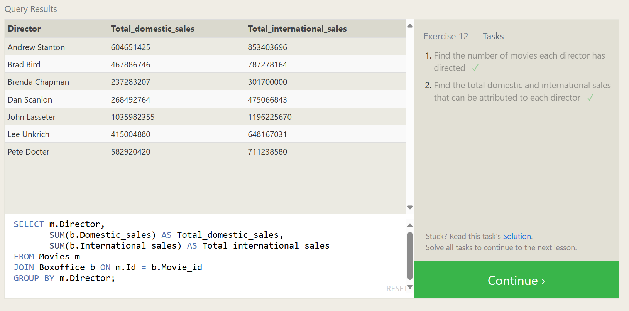

**Exercise 13 — Tasks Completed:**

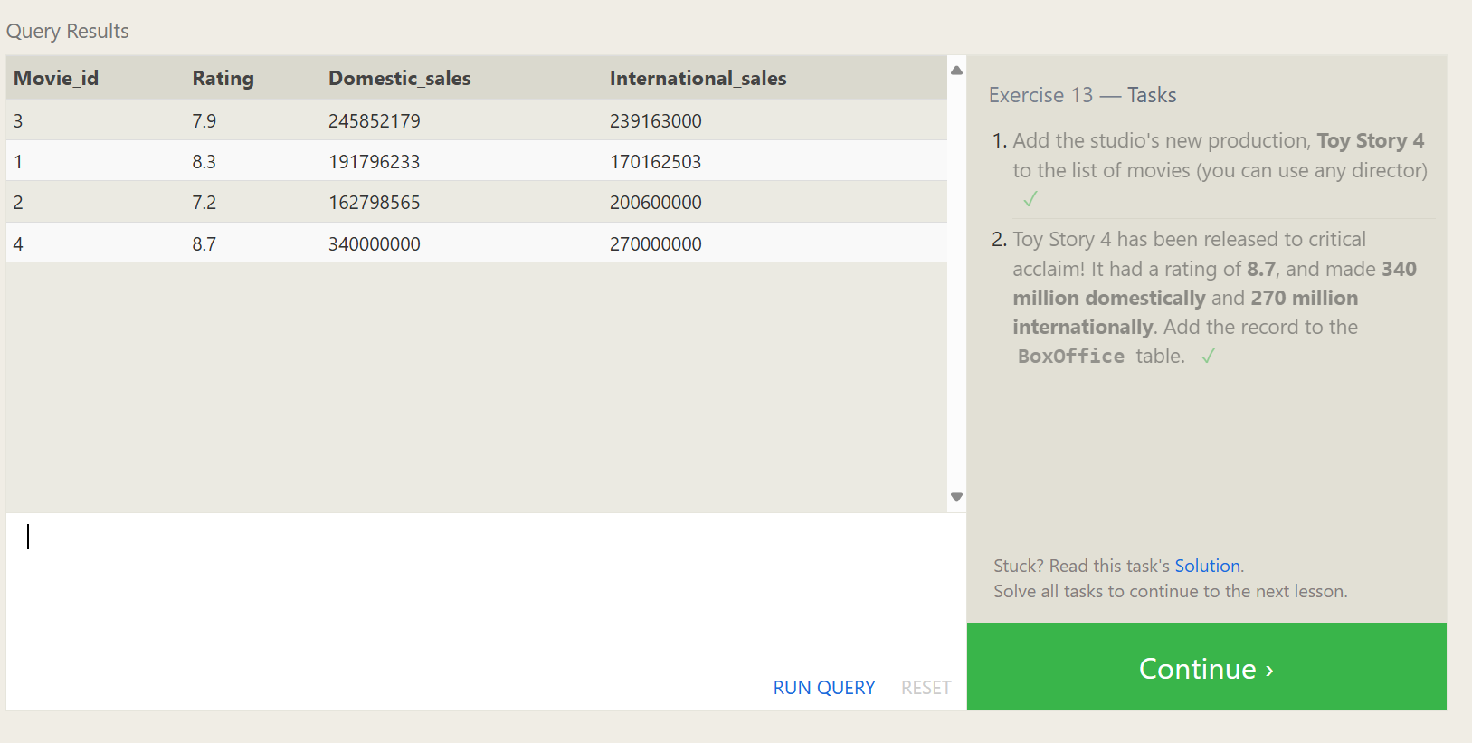

**Exercise 14 — Tasks Completed:**

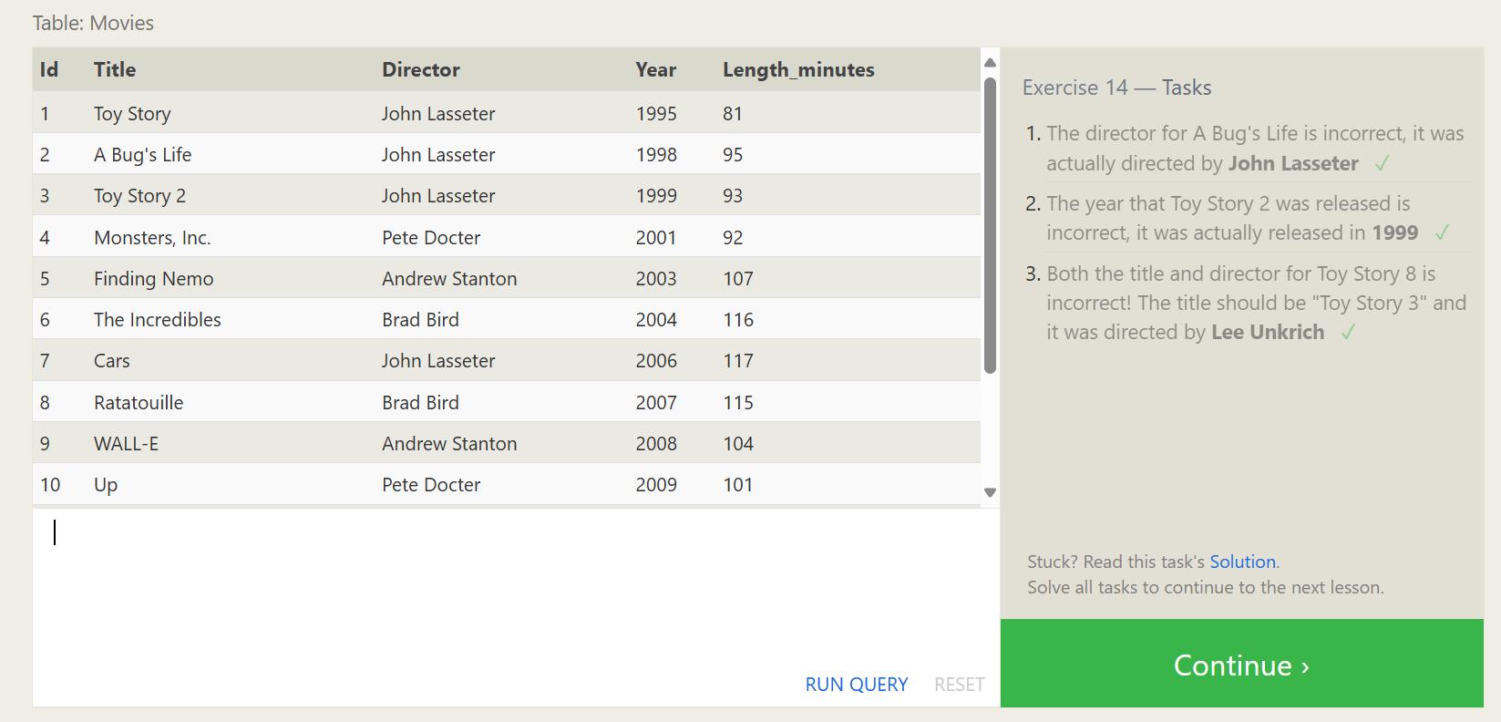

**Exercise 15 — Tasks Completed:**

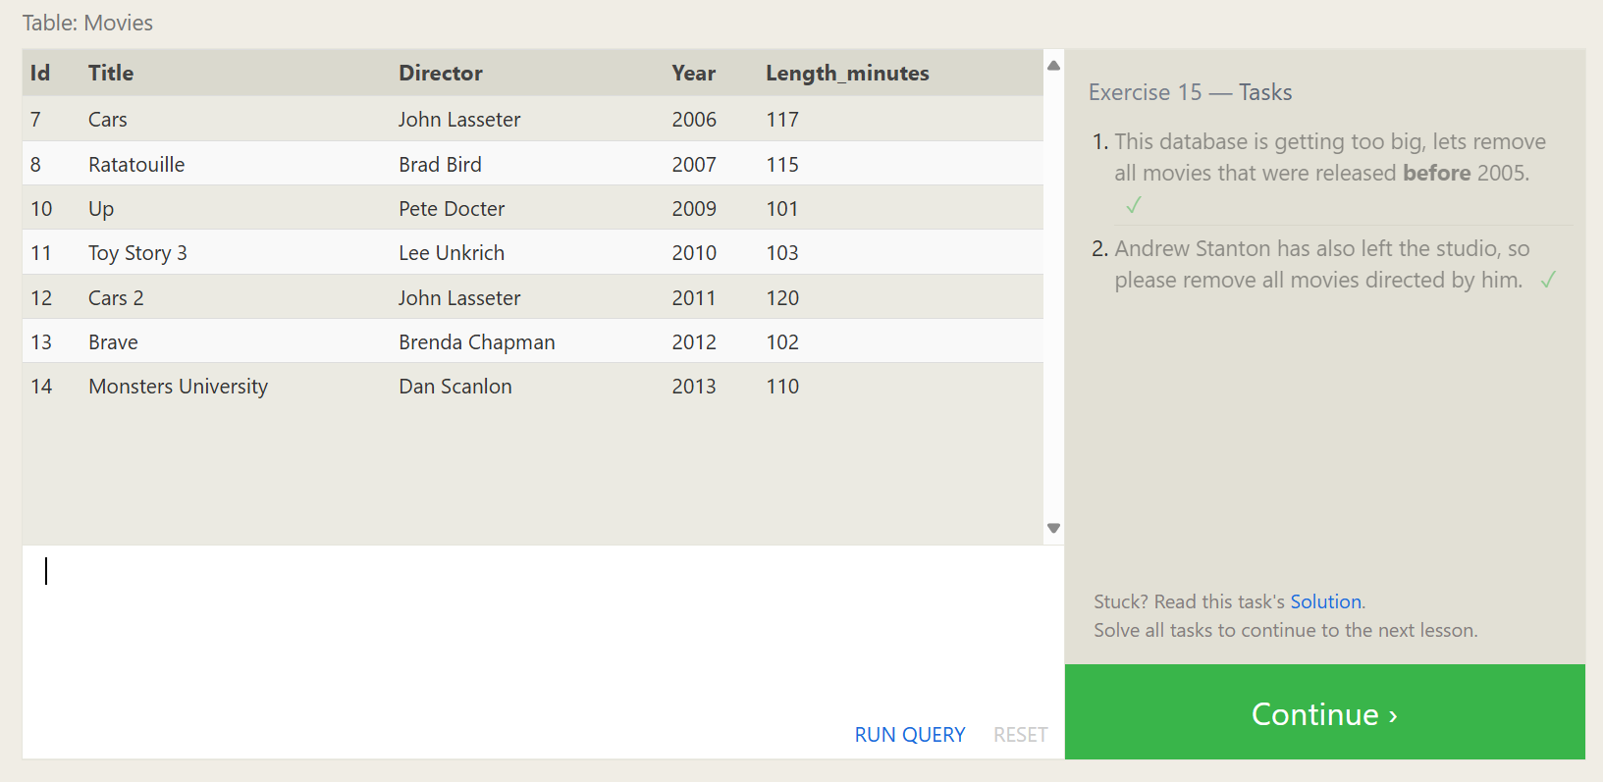

**Exercise 16— Tasks Completed:**

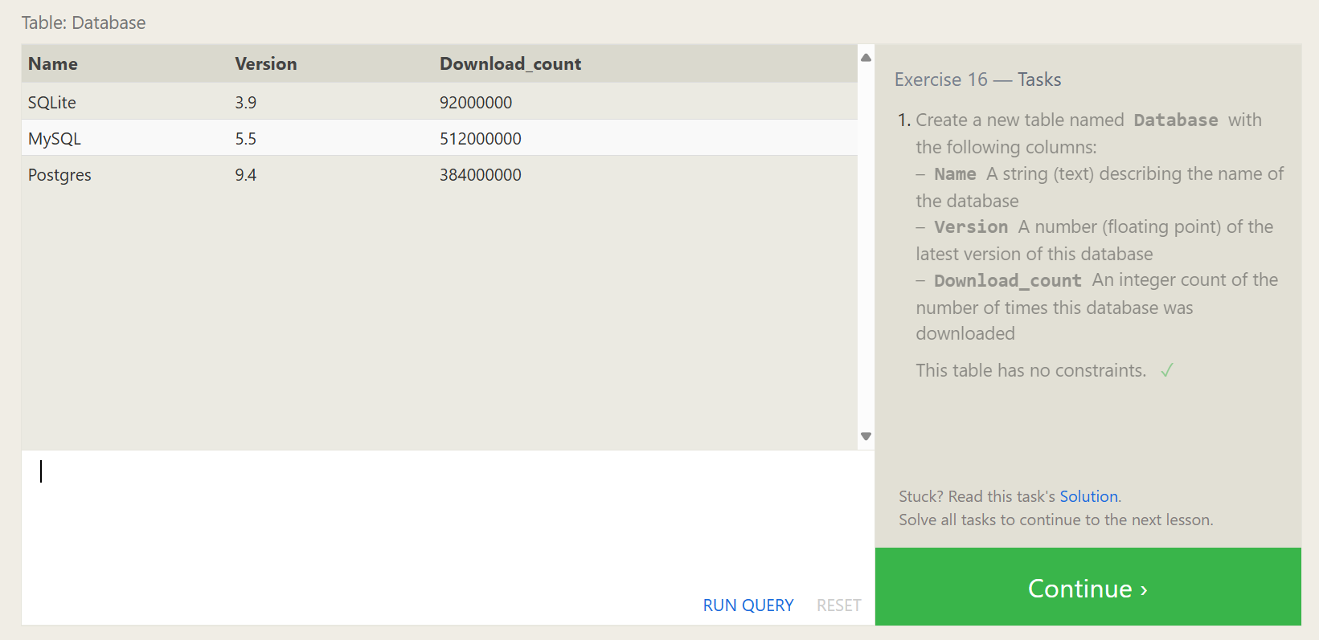

**Exercise 17— Tasks Completed:**

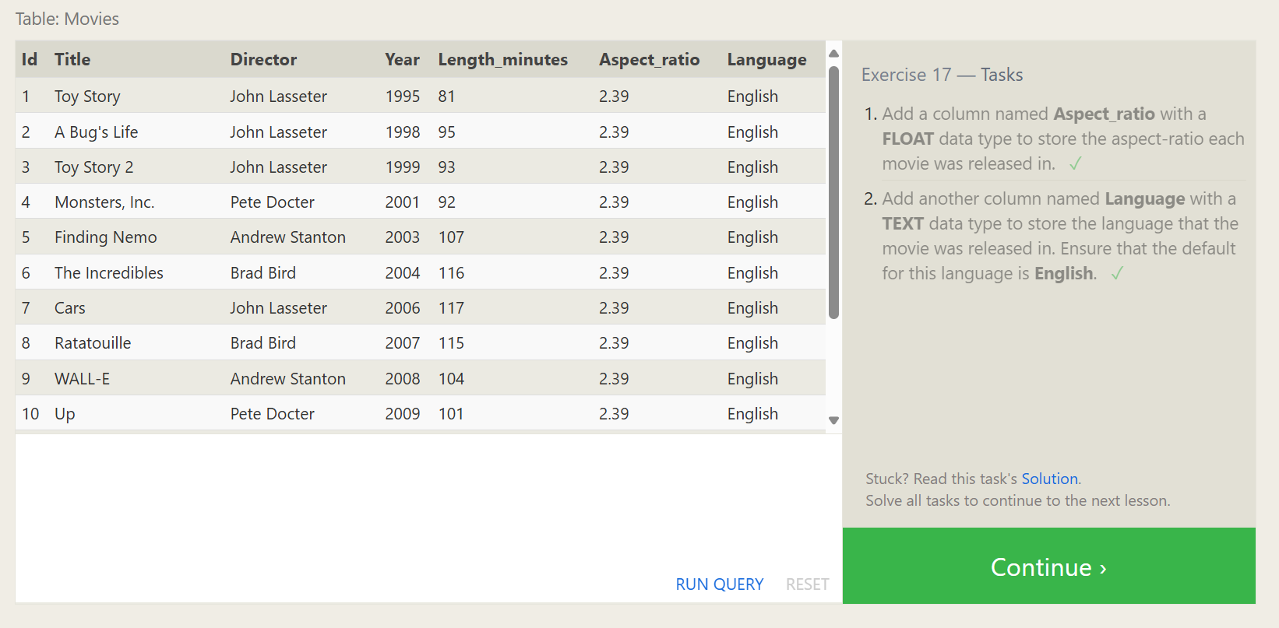

**Exercise 18— Tasks Completed:**

